**Assignment – Data Aggregation Activity – Josée Gosselin**

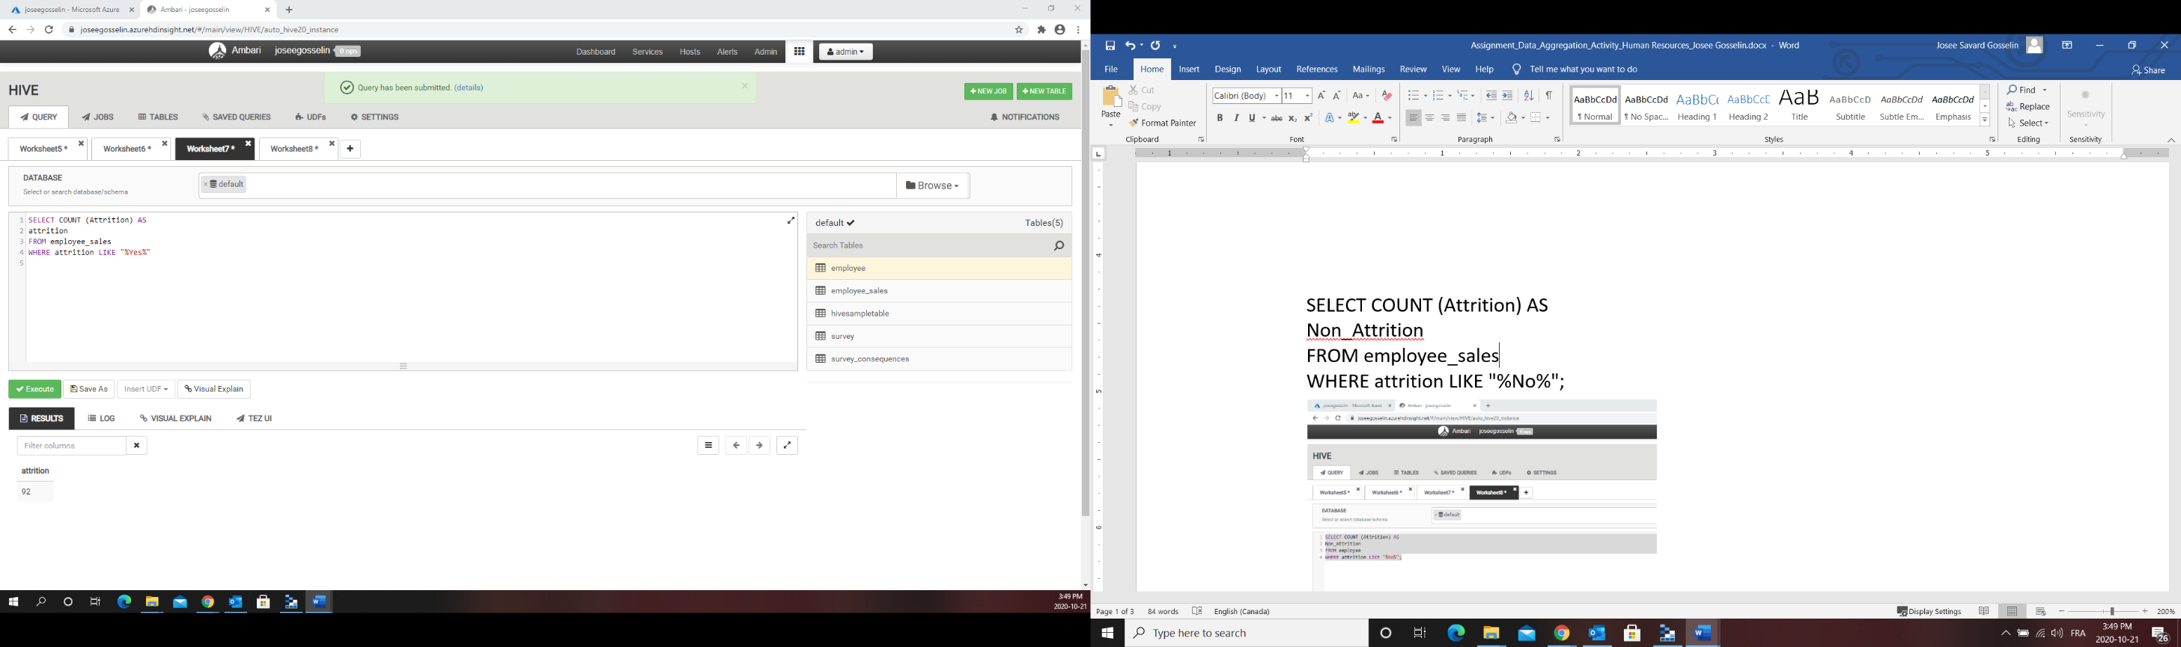**Query 1**

SELECT COUNT (Attrition) AS

attrition

FROM employee_sales

WHERE attrition LIKE "%Yes%"

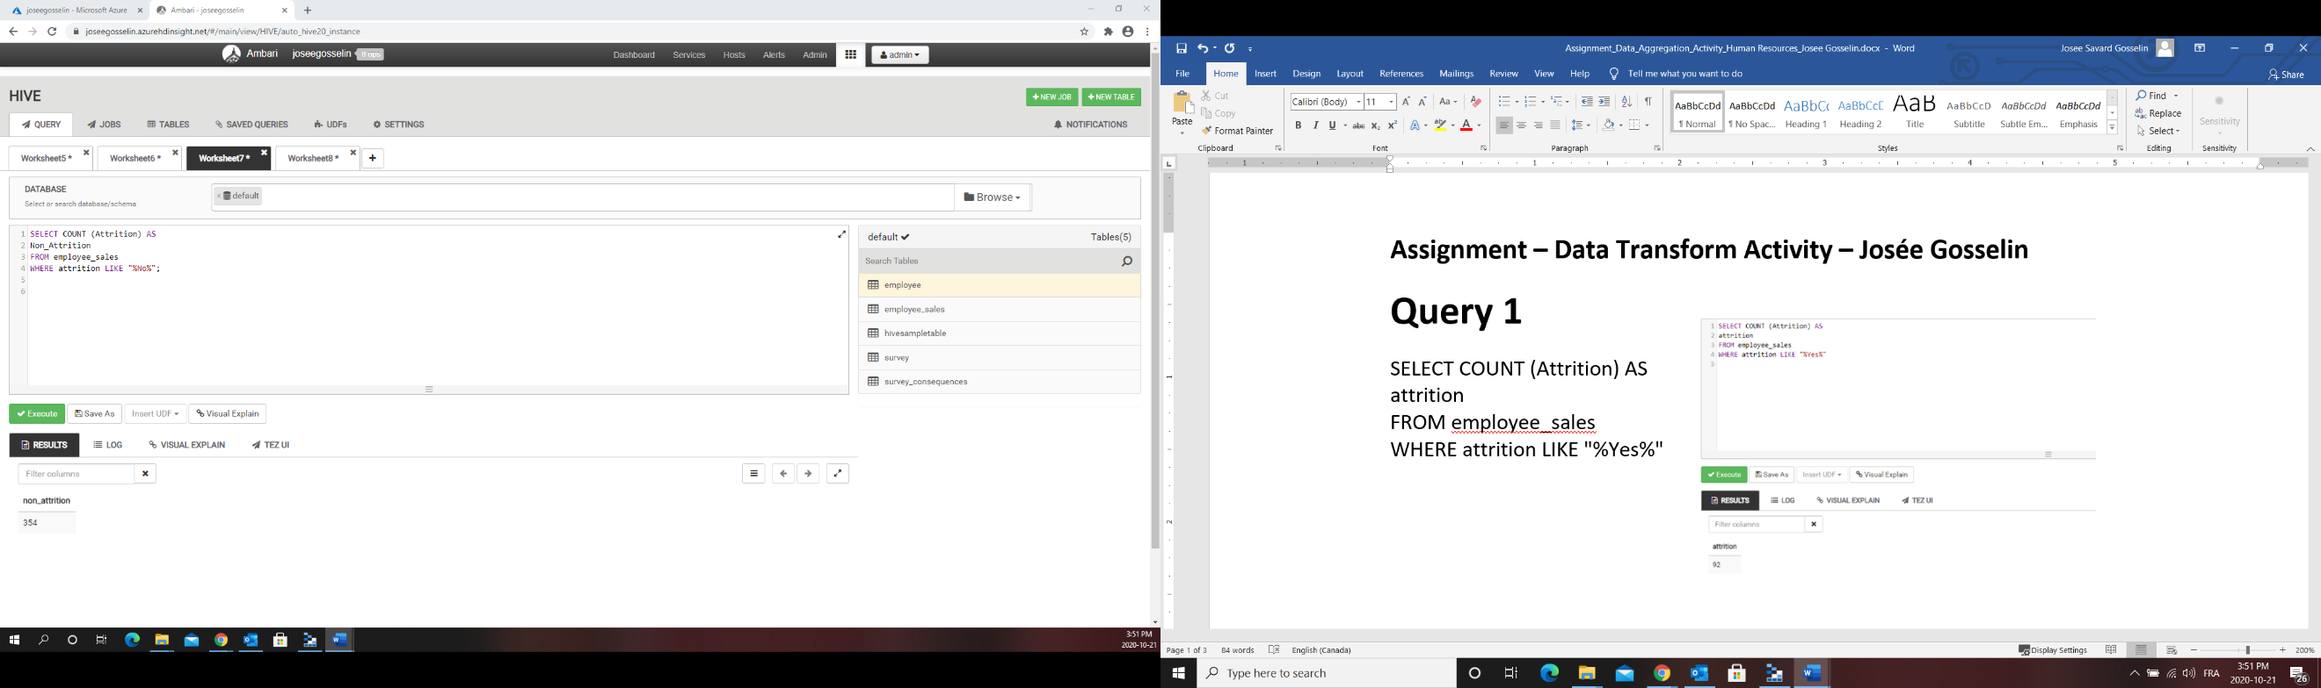

SELECT COUNT (Attrition) AS

Non_Attrition

FROM employee_sales

WHERE attrition LIKE "%No%";

**QUERY 2**

SELECT AVG(MonthlyIncome) AS average_monthly_income, MIN(MonthlyIncome) AS min_monthly_income, MAX(MonthlyIncome) AS max_monthly_income

FROM employee_sales;

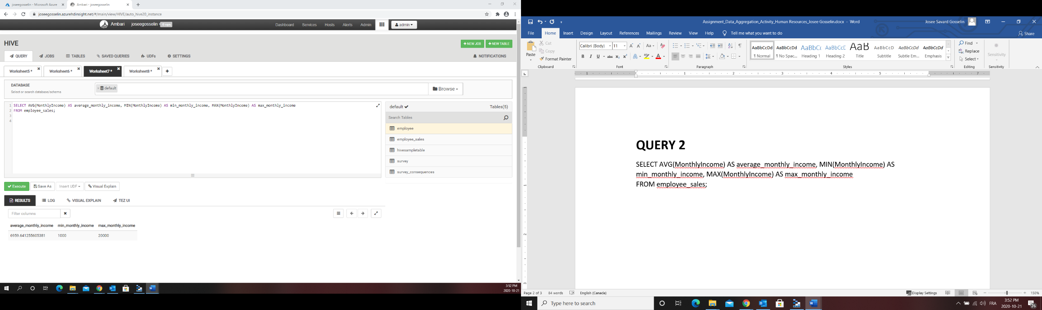

SELECT AVG(MonthlyIncome) AS average_monthlyincome_attrition, MIN(MonthlyIncome) AS min_monthlyincome_attrition, MAX(MonthlyIncome) AS max_monthlyincome_attrition

FROM employee_sales

WHERE attrition LIKE "%Yes%";

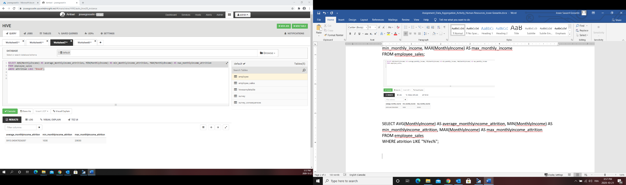

SELECT AVG(MonthlyIncome) AS average_monthlyincome_non_attrition, MIN(MonthlyIncome) AS min_monthlyincome__non_attrition, MAX(MonthlyIncome) AS max_monthlyincome_non_attrition

FROM employee_sales

WHERE attrition LIKE "%No%";

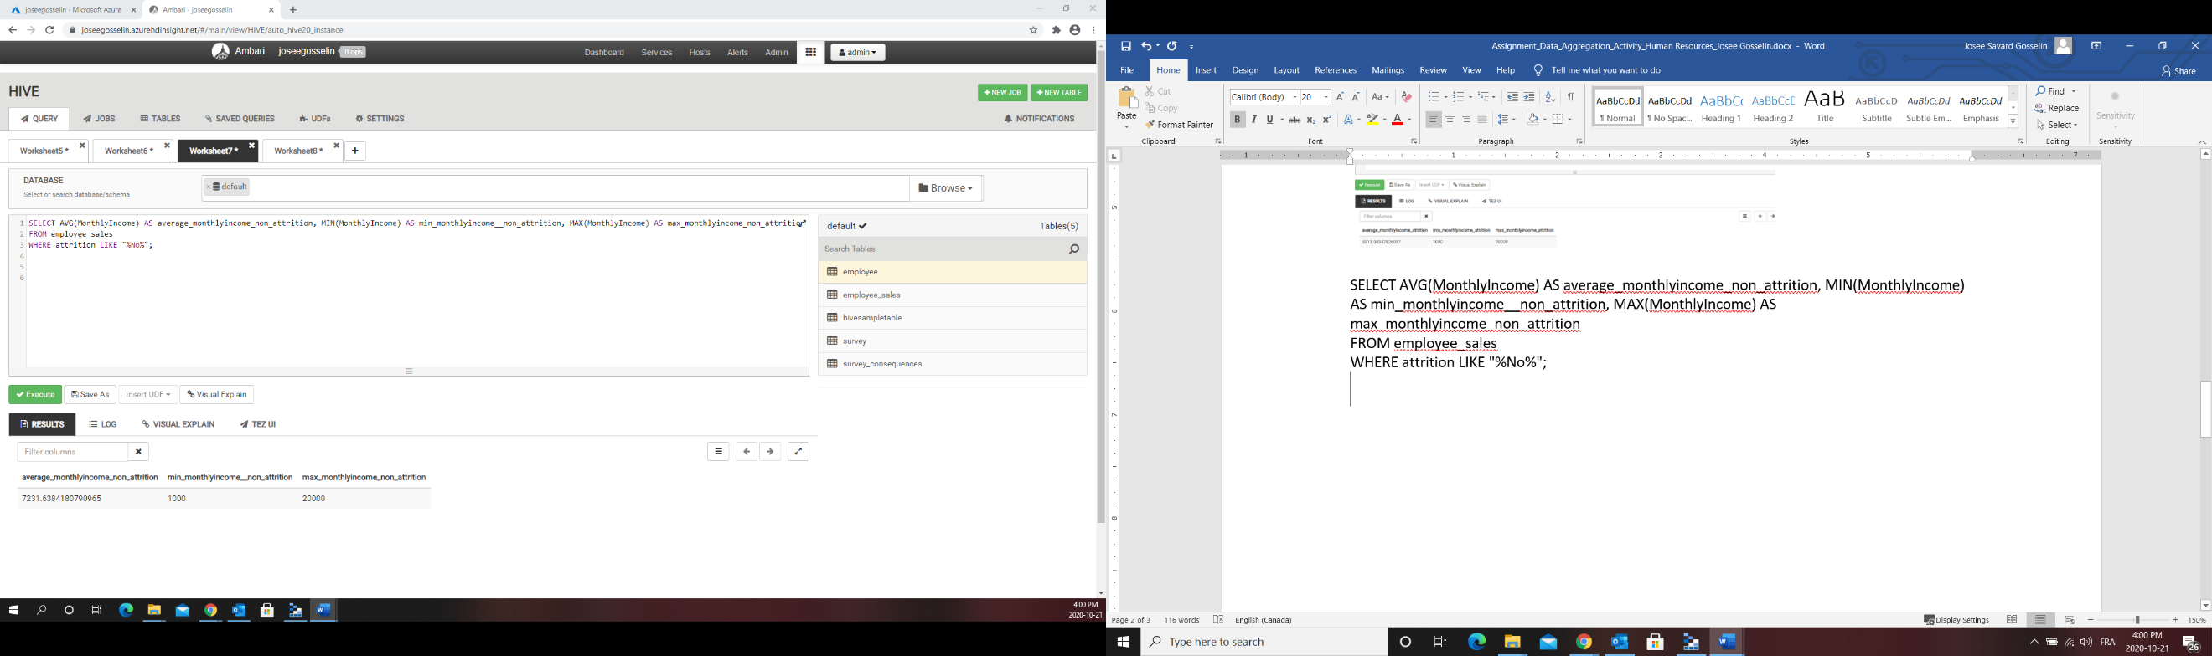

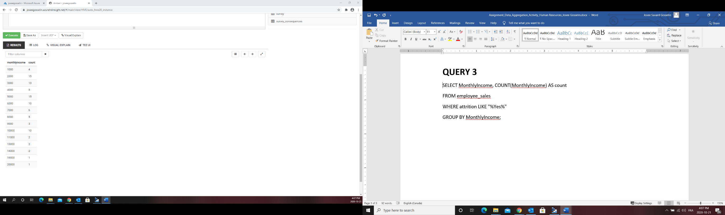**QUERY 3**

SELECT MonthlyIncome, COUNT(MonthlyIncome) AS count

FROM employee_sales

WHERE attrition LIKE "%Yes%"

GROUP BY MonthlyIncome;

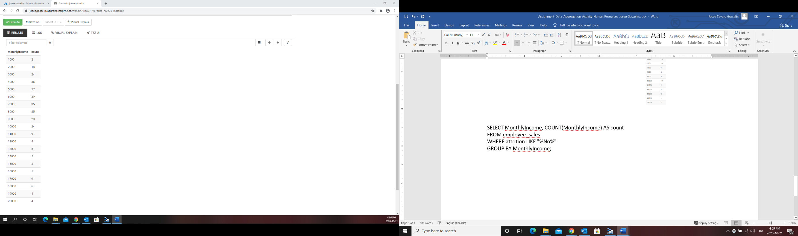

SELECT MonthlyIncome, COUNT(MonthlyIncome) AS count

FROM employee_sales

WHERE attrition LIKE "%No%"

GROUP BY MonthlyIncome;